LAB 6.3
Task Description #1: Classes (Student Class)
Scenario: You are developing a simple student information management module
Prompt used:
# develop a simple student management module
# the class should include attributes such as name,roll number,and branch
# add a method to display student details
#take as user input values for at least 4 students and display their details using the method
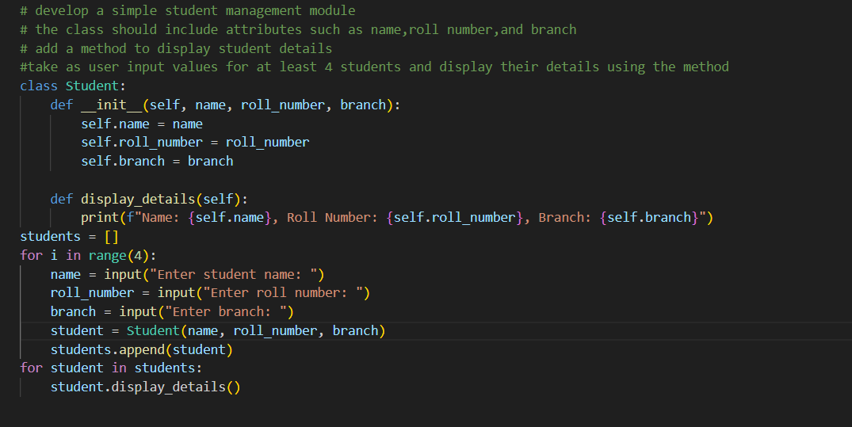
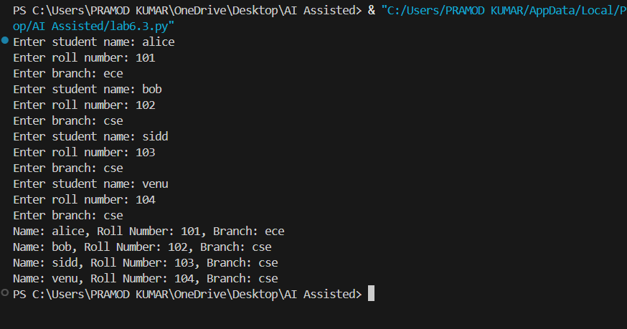

Task Description #2: Loops (Multiples of a Number)
Scenario: You are writing a utility function to display multiples of a given number
Prompt used: generate a python function to display the multiples of a given number
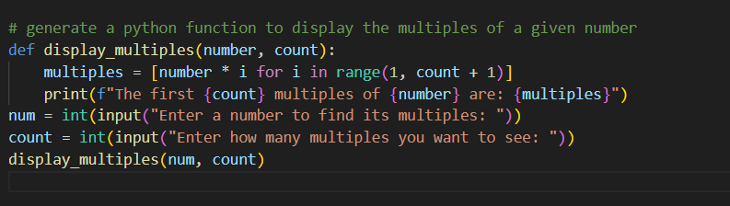
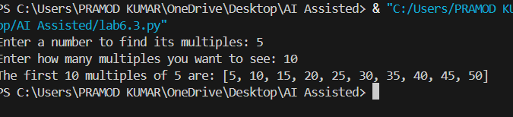

Task Description #3: Conditional Statements (Age Classification)
Scenario: You are building a basic classification system based on age.
Prompt used:
"# Generate a Python function that classifies a person’s age into groups (child, teenager, adult, senior) using nested if-elif-else statements.
# explain the logic clearly, then rewrite the same classification using an alternative approach such as simplified conditions or dictionary-based logic.
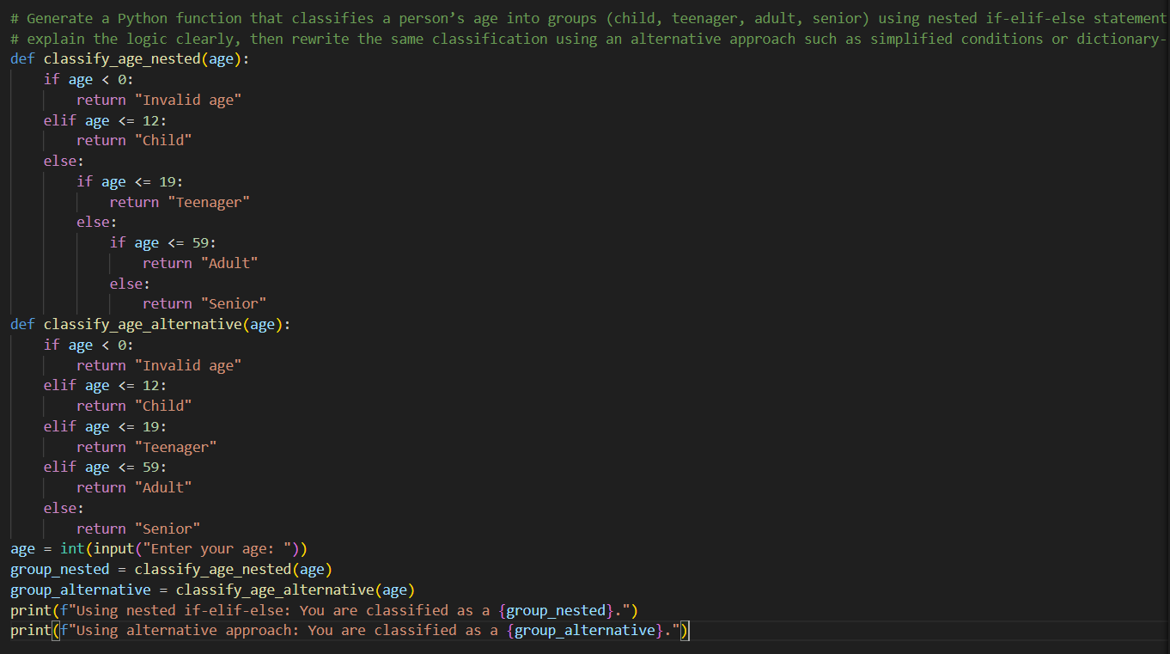
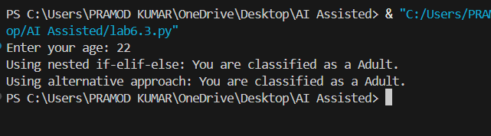

Task Description #4: For and While Loops (Sum of First n Numbers)
Scenario: You need to calculate the sum of the first n natural numbers.
Prompt used:
# Generate a Python function that calculates the sum of the first n natural numbers using a for loop.
# explain how the loop works, then provide alternative implementations using a while loop and a mathematical formula.
# and compare all approaches with sample inputs and outputs
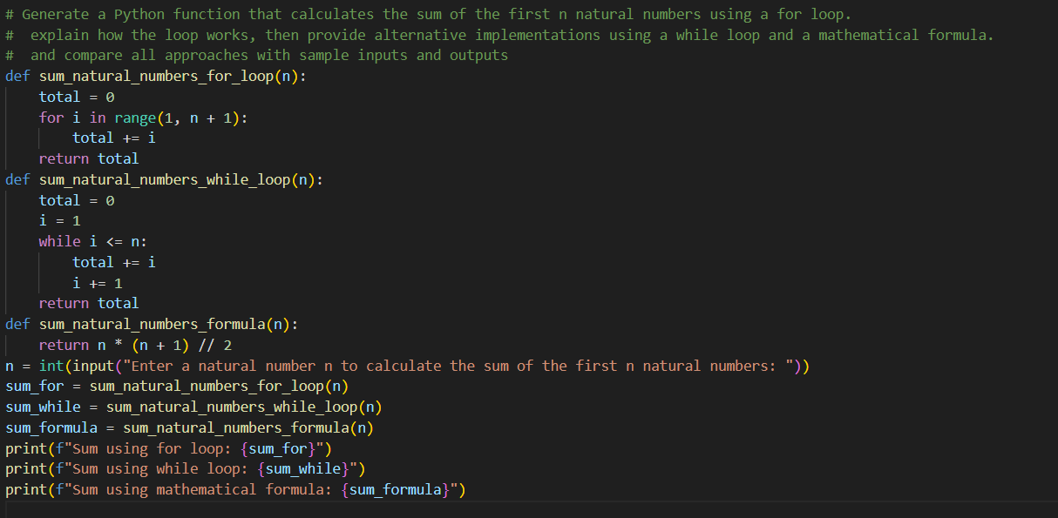
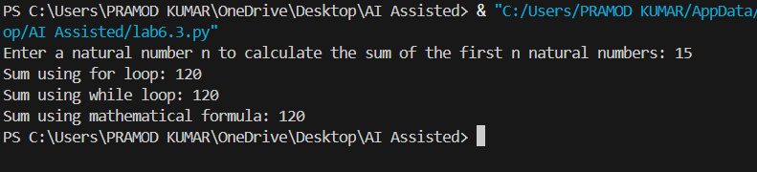

Task Description #5: Classes (Bank Account Class)
Scenario: You are designing a basic banking application
Prompt used:
# Generate a complete Python BankAccount class with methods deposit(), withdraw(), and check_balance().
# demonstrate deposit and withdrawal operations with updated balances, add meaningful comments in the code
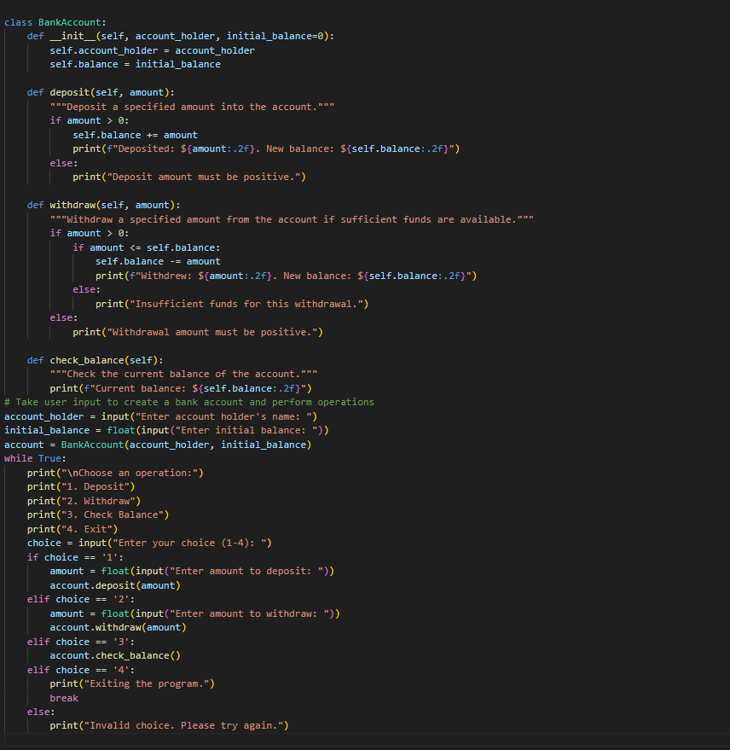
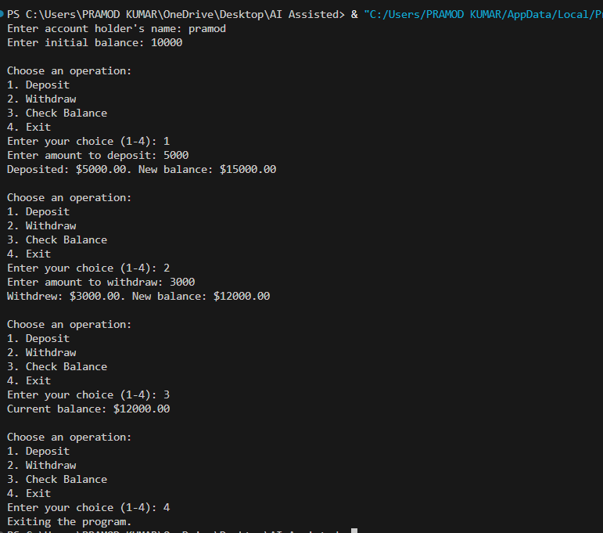

EXPLANATION:
1. The first code defines a Student class to manage student details and displays information for multiple students based on user input.
2. The second code defines a function to display multiples of a given number based on user input.
3. The third code classifies a person's age into groups using nested if-elif-else statements and an alternative approach.
4. The fourth code calculates the sum of the first n natural numbers using three different methods: for loop, while loop, and mathematical formula.
5. The fifth code implements a BankAccount class with methods for depositing, withdrawing, and checking balance, allowing user interaction for banking operations.

